**STEP 1:** Install the Microsoft Power BI desktop app for the windows.

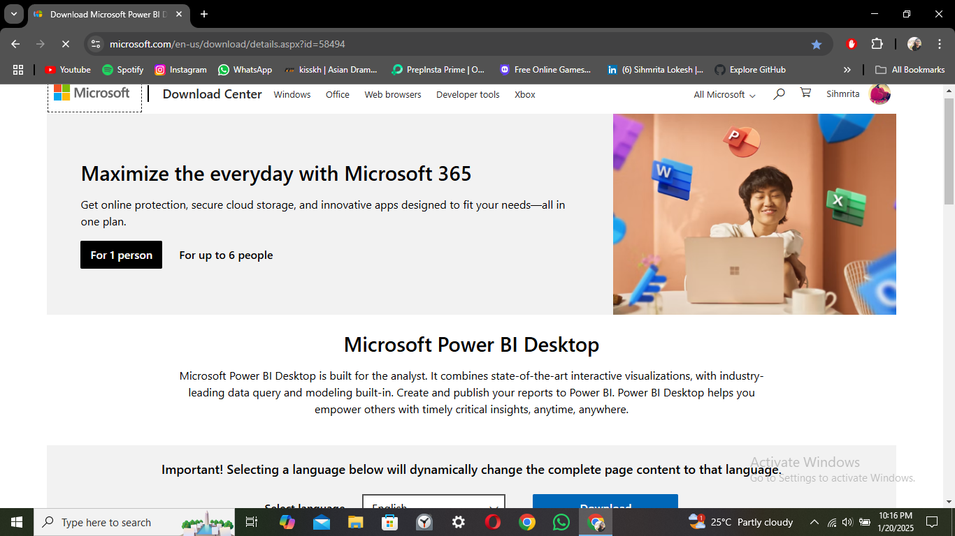

**STEP 2:** Open the front page of the power BI app. Click on the blank report to start a new project.

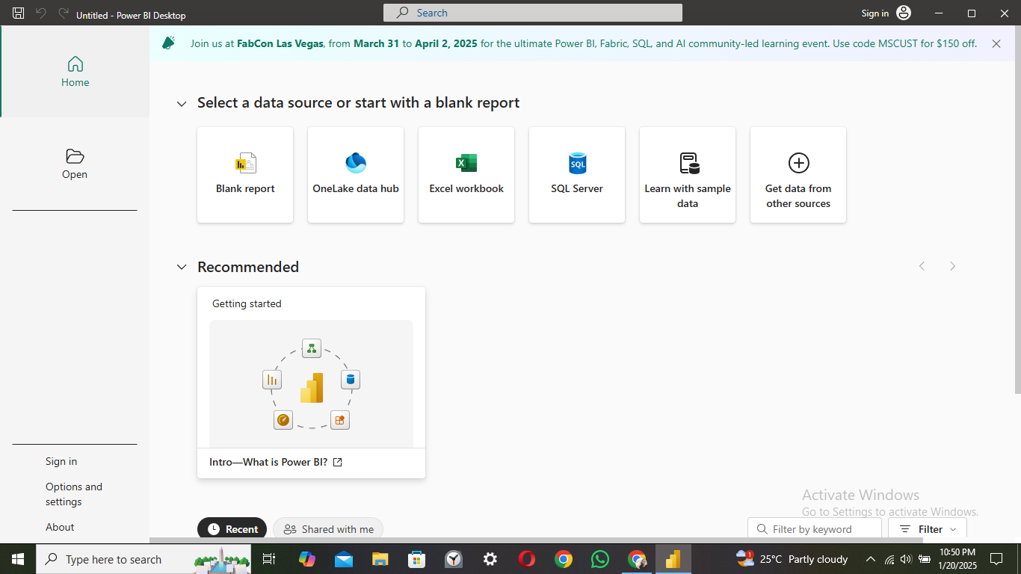

**STEP 3:** Click on the Get data bin to load the required dataset file that is pre-installed in the system files with extensions like .csv, .exe, etc.,

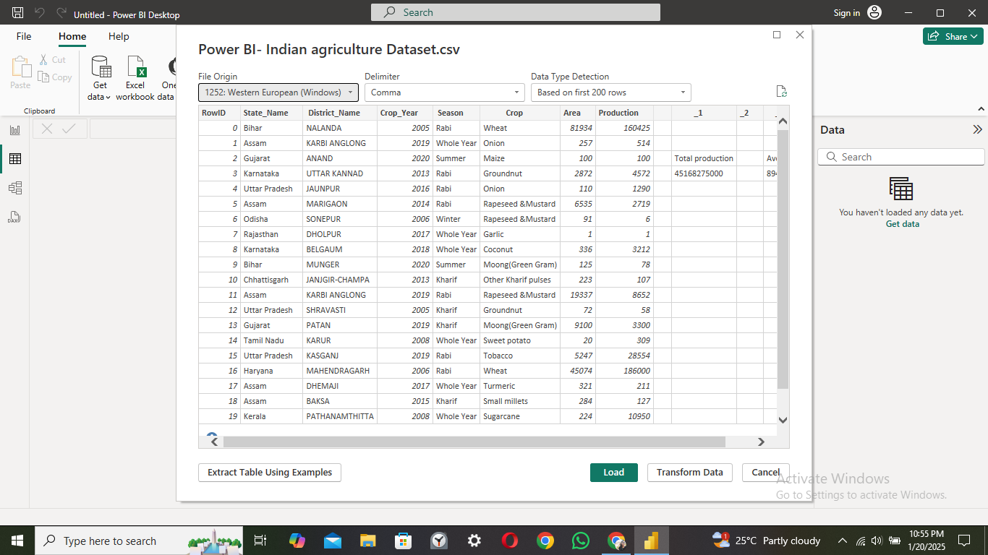

**STEP 4:** Dataset is loaded successfully and to view the dataset click on the table in the left side of the page.

**STEP 5:** Click on the Transform data option to modify the loaded dataset.

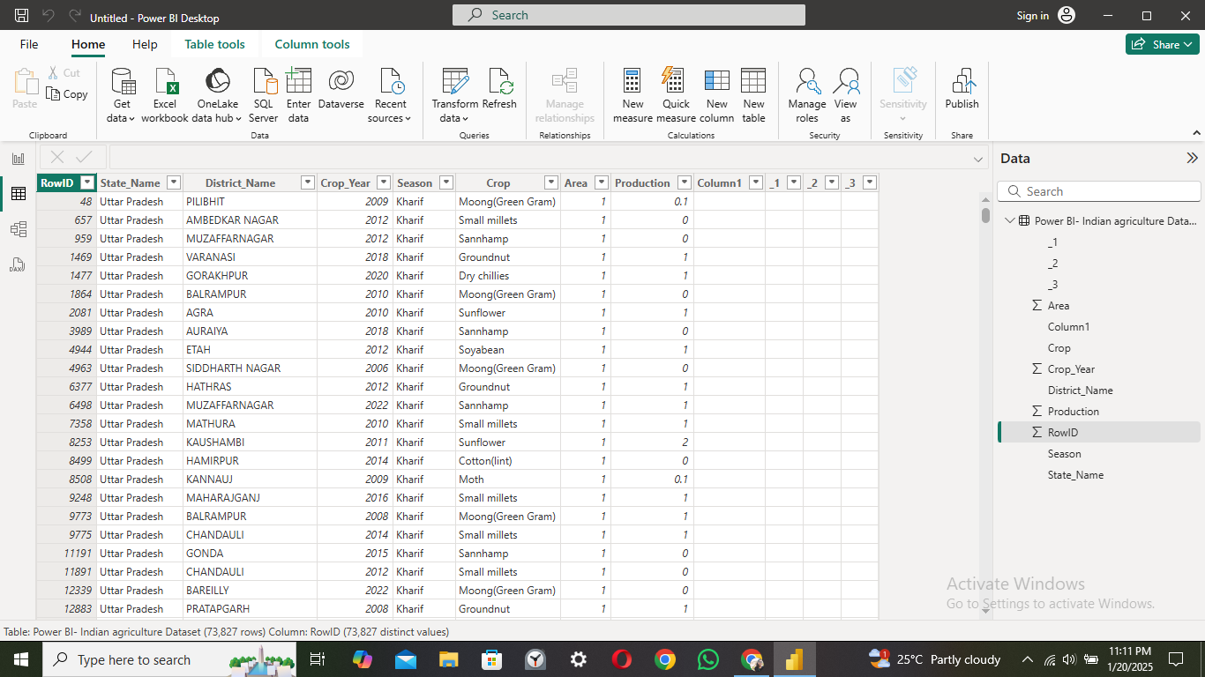

**STEP 6:** To remove the unrequired columns. Right click on the column name and remove them.

To delete multiple columns click control to select and right click the column names to remove.

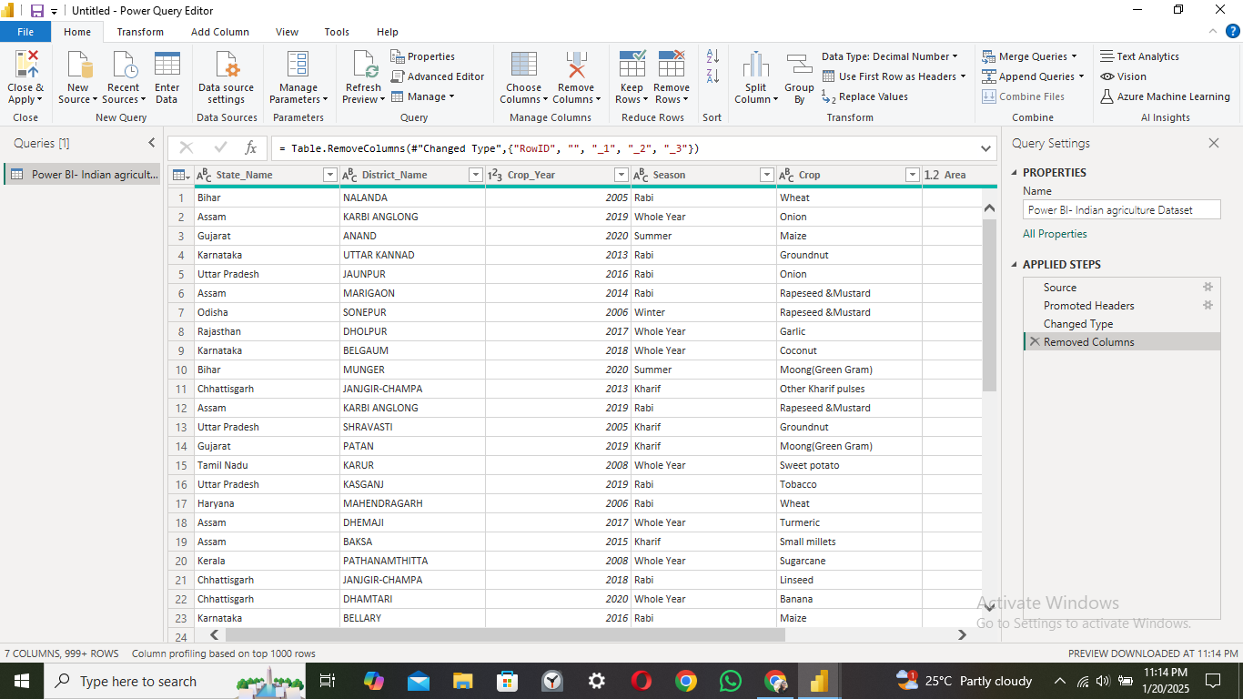

**STEP 7:** Click on the view in the taskbar to check the column quality.

Column quality provides the details of error values and null values.

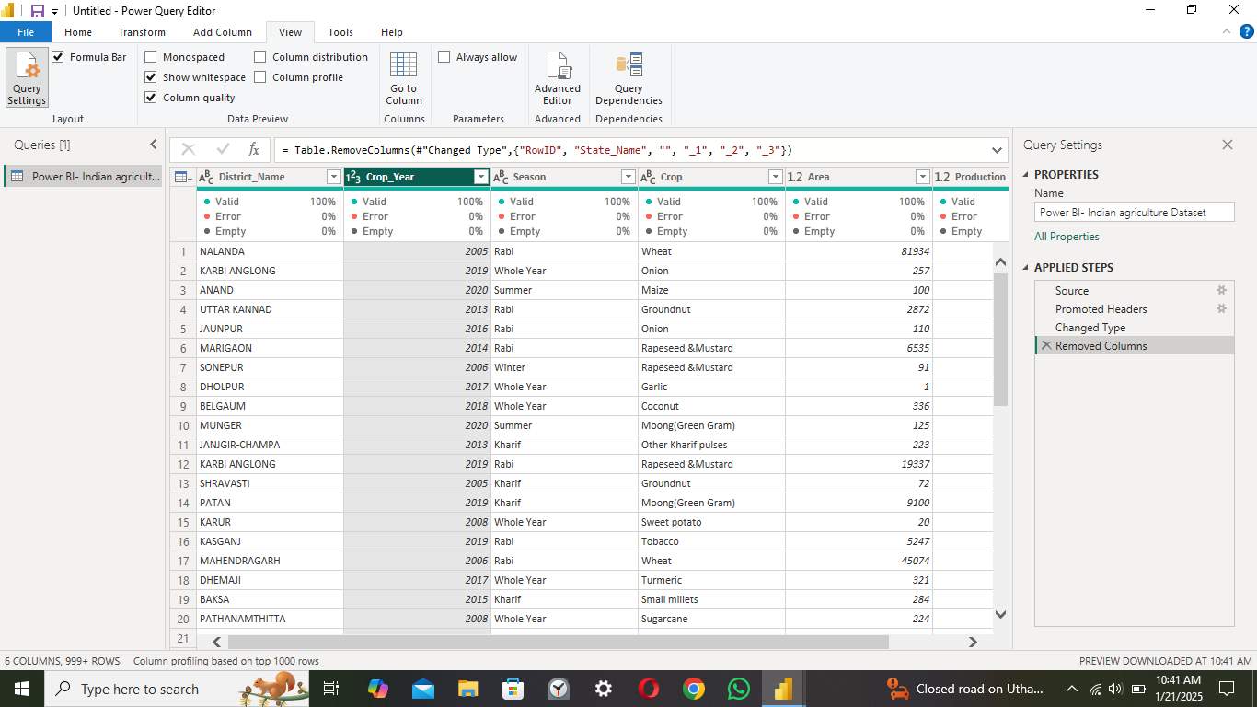

**STEP 8:** If the dataset contains null values or errors or duplicate values then Click on the Remove rows option to modify the dataset.

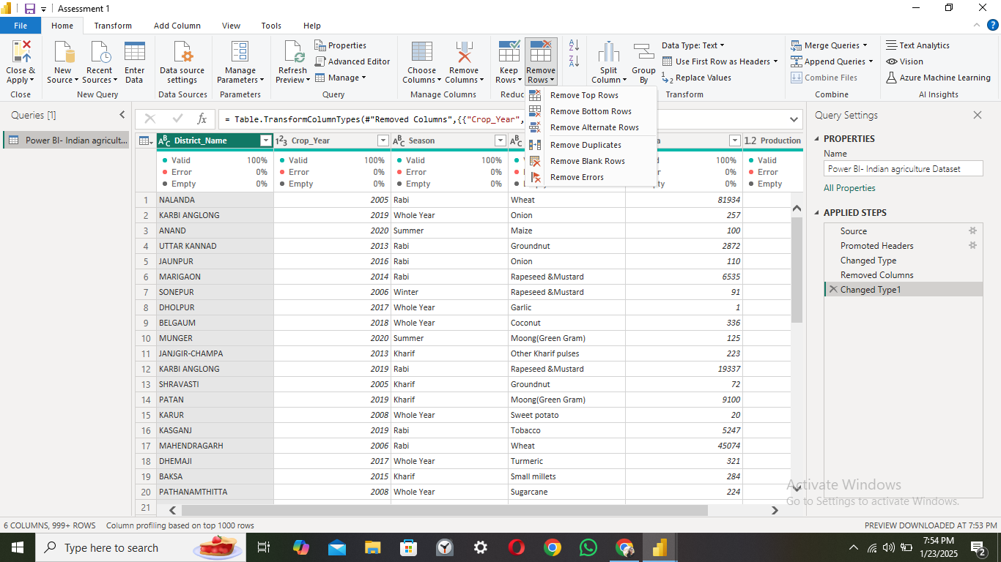

**STEP 9:** Click the close and apply option to save the modifications.

This image shows the steps that we applied previously. Can be viewed in the right side of the page while doing the modifications.

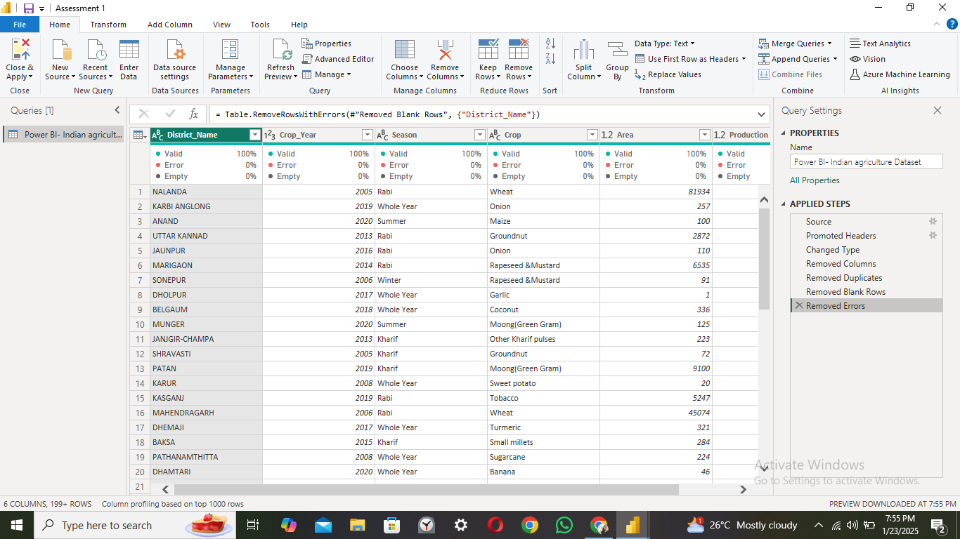

**STEP 10:** The dataset is now ready for further processing of the project.

